Samarth Rural Educational Institute’s
Samarth College of Computer Science, Belhe
Academic Year 2026-2027(SEM-V)
T.Y.B.Sc.(Information Technology)
Practical NO:3
Title : 3. Flask Installation and Setup
Roll NO: 70 Batch : C

Set A
Q1. Create a Flask application displaying "Hello World".
Ans:
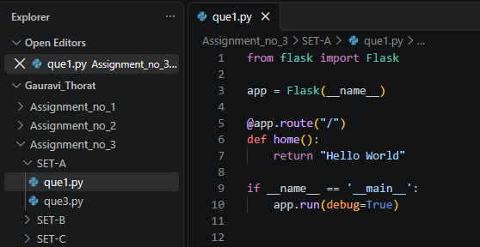
Output:
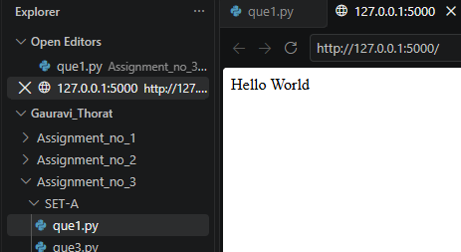
Q2. Create a Flask application displaying your name and roll number.
Ans:
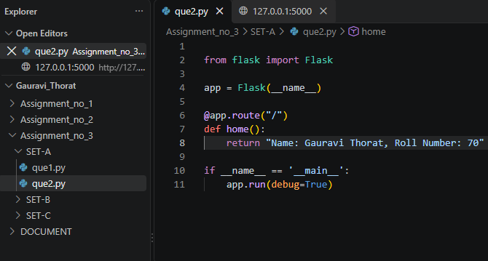
Output:
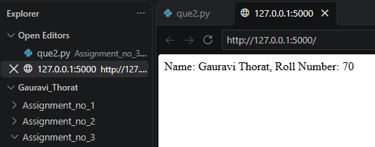

Set B
Q3. Create a Flask application displaying current date and time.
Ans:
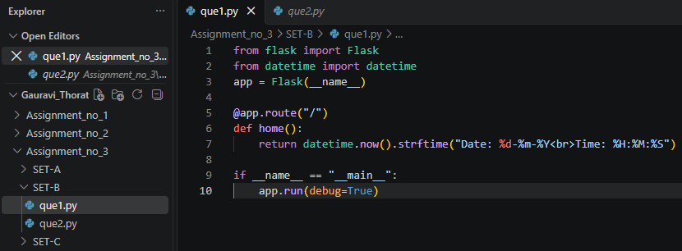
Output:
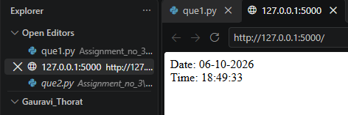

Set C
Q4. Create a Flask application displaying system information using routes.
Ans:
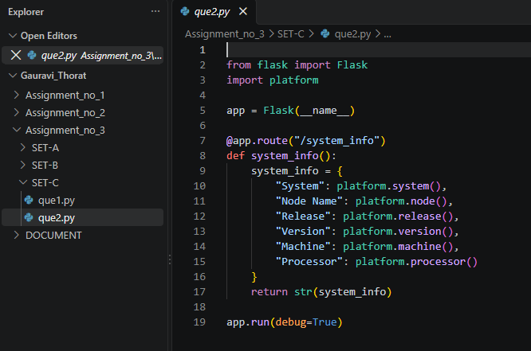
Output:
